|  |  |  |  |  |  |
| --- | --- | --- | --- | --- | --- |
| **Module No:** | 6 | **IU No:** | 4 | **Exercise No.** | 4 |

**Name : SyukurSidiqNurAlam  
Code : BDSE-0922-089/STTB**

|  |  |
| --- | --- |
| **Lab Assessment Statement** | **Assignment 4 – Setup the development environment and Develop MVC Portlet**  **Referring to Assignment-1's Project Scenario,**  In this assignment, you need to set up the development environment to develop a Liferay application. After setting up, you have been tasked to create the MVC Portlet with the names "FeedbackPortlet".  **1. Setup the Liferay IDE development environment as follows:**   * Download Liferay Eclipse IDE. * Open Eclipse and Choose Liferay Workspace * Define new server from Server Tab * Choose Liferay v6.2 CE Server from Liferay, Inc. * Specify the installation directory of the Tomcat configured with Liferay * Select runtime JRE (prefer JDK is 1.7)   + JDK 1.7 is compatible with Liferay 6.2 to develop the Service Builder * Click finish * Start the Tomcat server, and * Access the Liferay home via http://localhost:8080/   **2. Create Feedback MVC Portlet**  Provide the sample demonstration are as follows:   * Create a new Liferay plugin project with a project name "newsportalFeedback". * Create Liferay MVC portlet (FeedbackPortlet) with package name "com.liferay.docs.feedback.portlet". * Create new JSP (feedback.jsp) and simply create actionURLs and Feedback Form to submit the feedback. * Implement controller (a portlet action) method to handle the Feedback form. You need to specify the portlet class action method **as the URL name** **attribute**. In the action method, get the form input data and print it. * In view.jsp, add the "Add New Feedback" link by using render URL tag. When the user clicks the link, the "Feedback form" appears. * Deploy the portlet. Enable and test the portlet.   **Provide caption and screen capture for each step.** |
| **Technical Environment** | - |
| **Guidelines** | - |
| **Duration** | 60 mins |

**1. Setup the Liferay IDE development environment as follows:**

* Download Liferay Eclipse IDE.  
  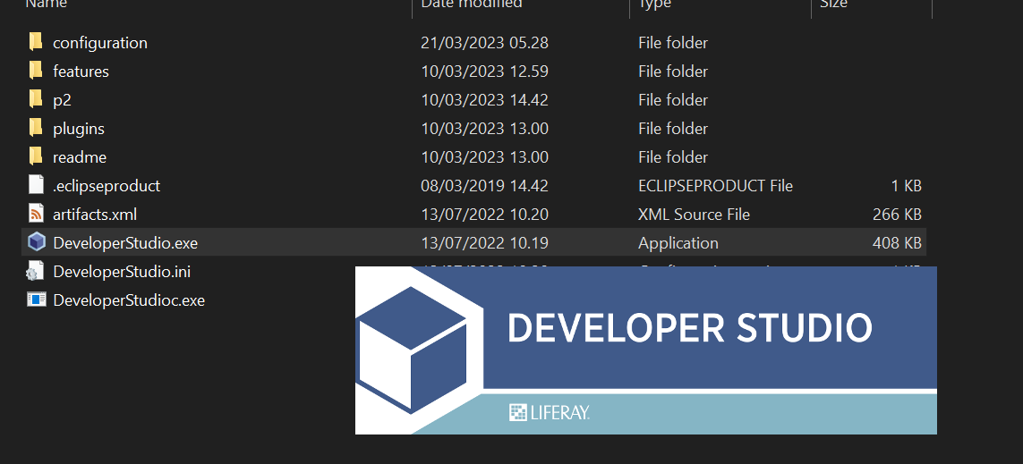
* Open Eclipse and Choose Liferay Workspace  
  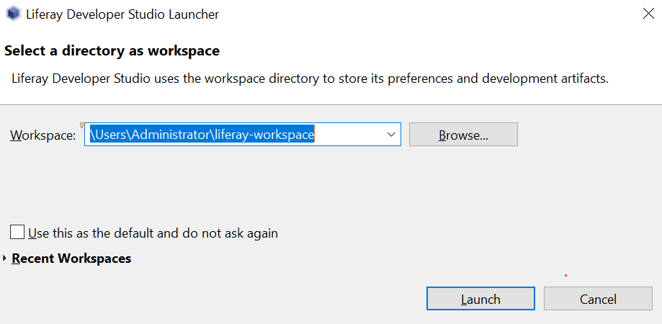
* Define new server from Server Tab  
   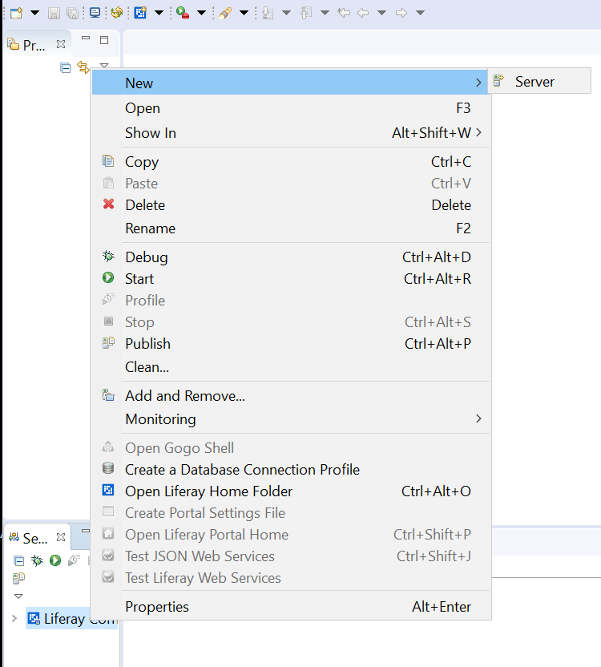
* Choose Liferay v7.x CE Server from Liferay, Inc.  
  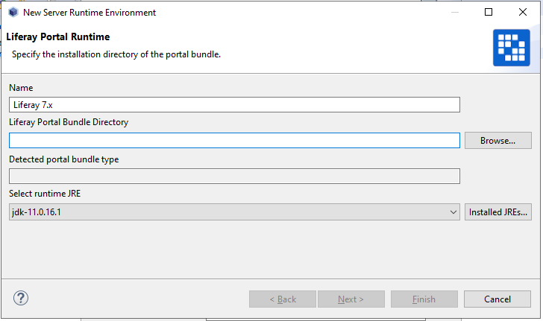
* Specify the installation directory of the Tomcat configured with Liferay  
  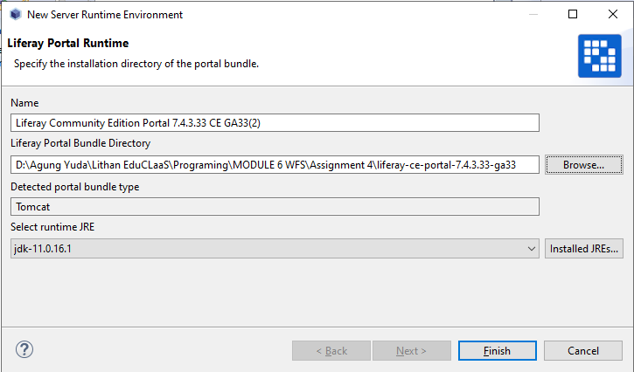
* Select runtime JRE (Using JDK 11)



* Click finish  
  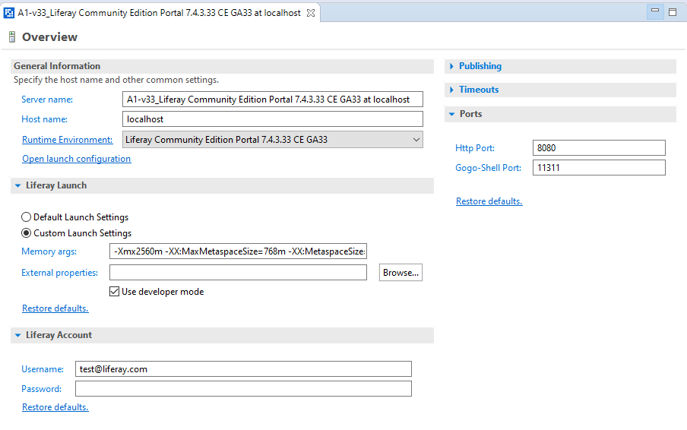
* Start the Tomcat server, and   
  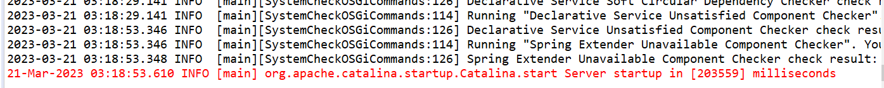
* Access the Liferay home via http://localhost:8080/  
  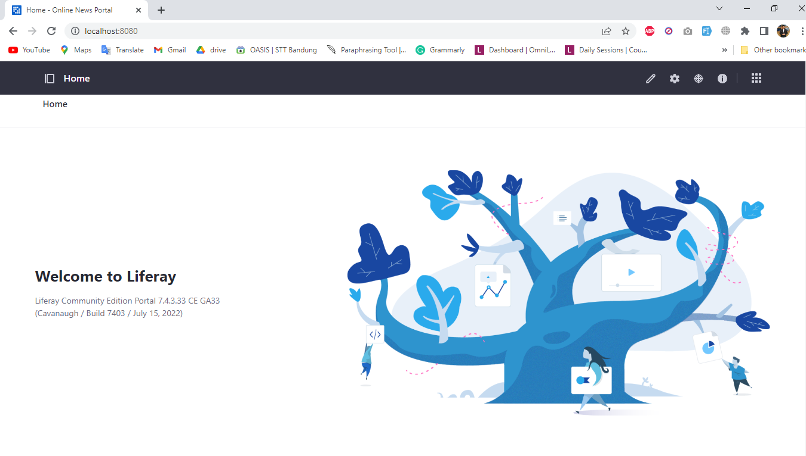

**2. Create Feedback MVC Portlet**

* Step 1 - Create a new Liferay plugin project with a project name "newsportalFeedback".  
   q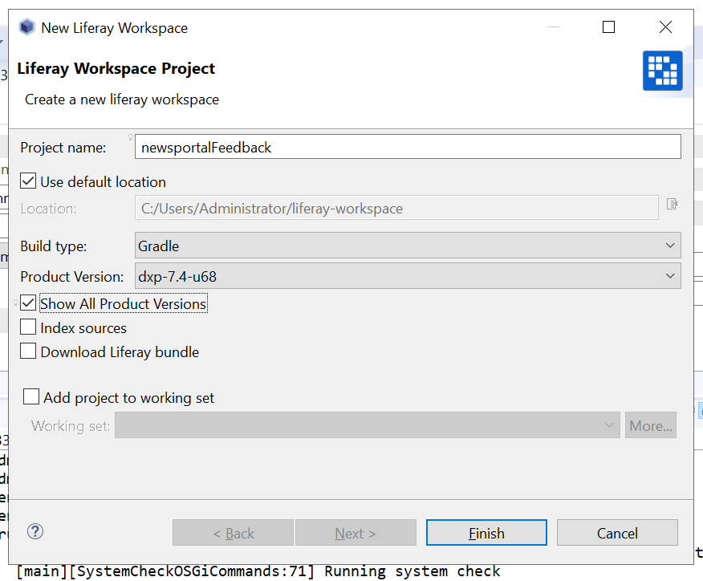
* Step 2 - Create MVC Portlet  
  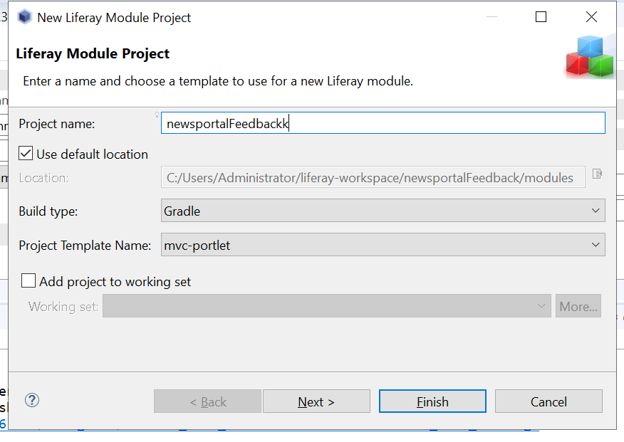

Click Finish

* Step 3 - Creating Jsp (add code)

Go to ser main resources, right click and new file, search for jsp and create jsp file  
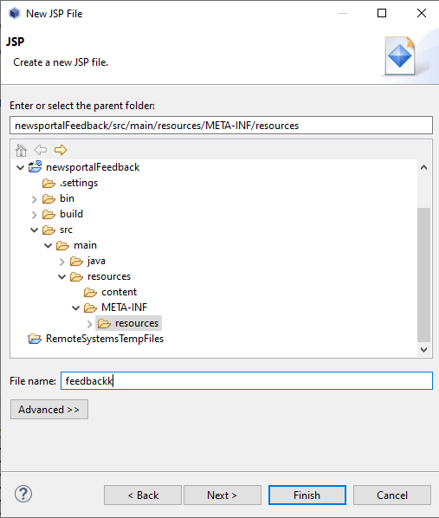

* Step 4 - Create function in controller
* 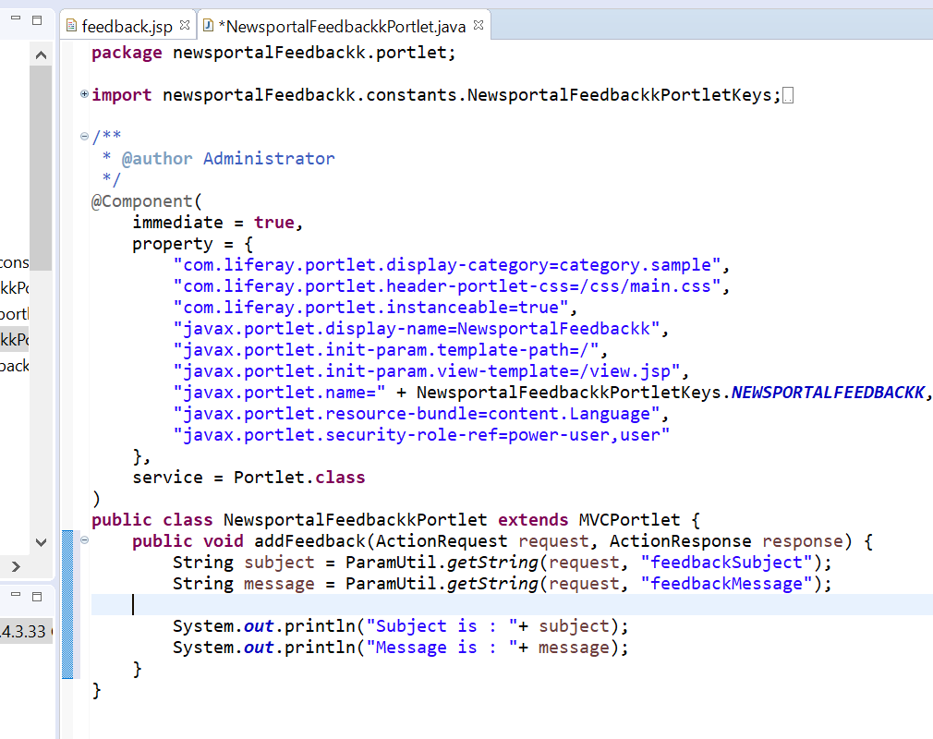
* Step 5 - view.jsp, add the "Add New Feedback" link by using render URL tag. When the user clicks the link, the "Feedback form" appears.

**views.jsp**  
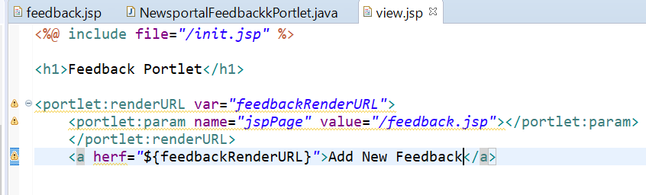

**feedback.jsp**  
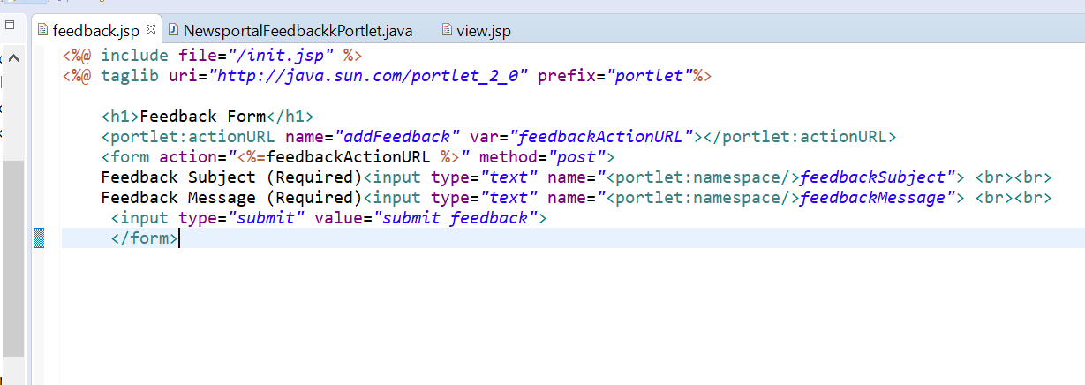

* Deploy the portlet. Enable and test the portlet.

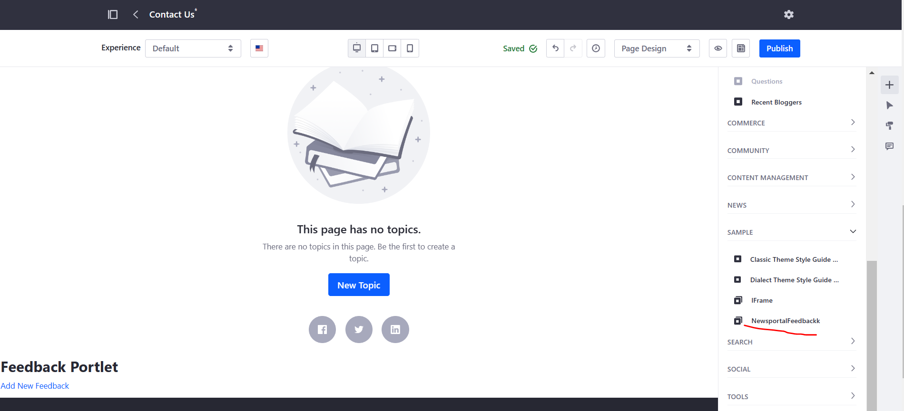

**Click Send Feedback link and Fill the forms**

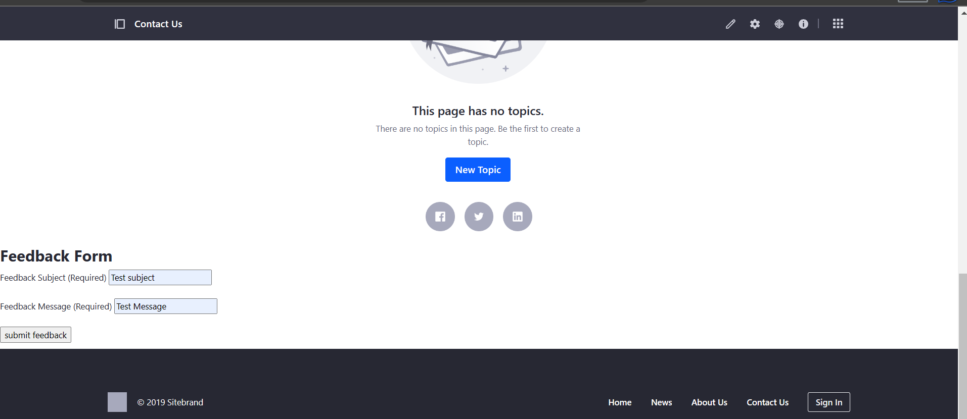

**Result**

